# Project Report Template

# INTRODUCTION :

Salesforce is a customer success platform ,designed help to sell ,service,market,analyze and connect with our customers.Running your business from anywhere with sales force. Use standard products and features to manage relationship with prospects and customers, collaborate and engage with employees and partners,and store a data securely in the cloud.

Salesforce is world leading CRM platform that caters to needs of over 150,000 clients of all business domains and sizes . If offers 20 off -the-shelf CRM suites called “clouds” that focus on various needs and industries .Among the most popular ones are sales cloud ,and marketing cloud .

As a CRM industry leader,sales force tries to fulfill the basic demands for the software of any business .And over 2,000 Salesforce consulting partners are ready to tweak the system to every tiny business request .

# Problem Definition and Design Thinking :

### Emapathy Map

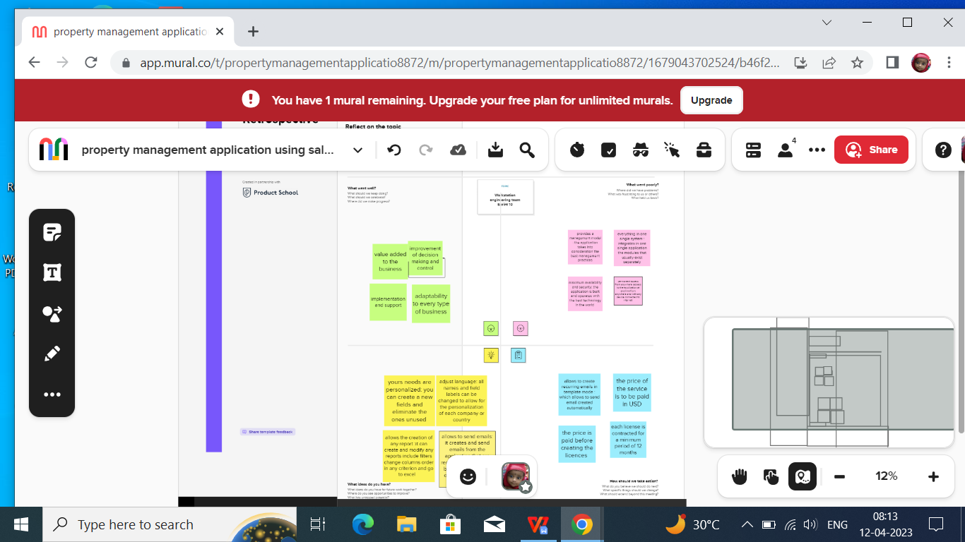

### Ideation and Brainstorming map Screenshot:

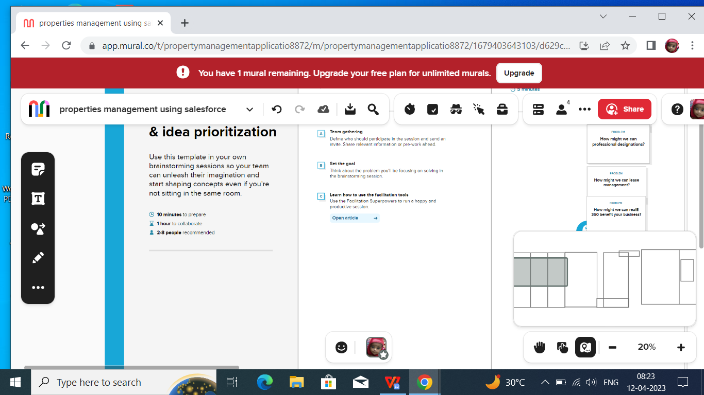

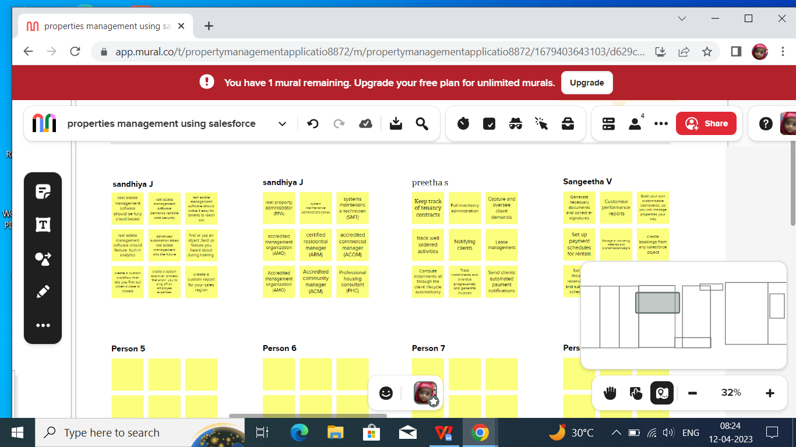

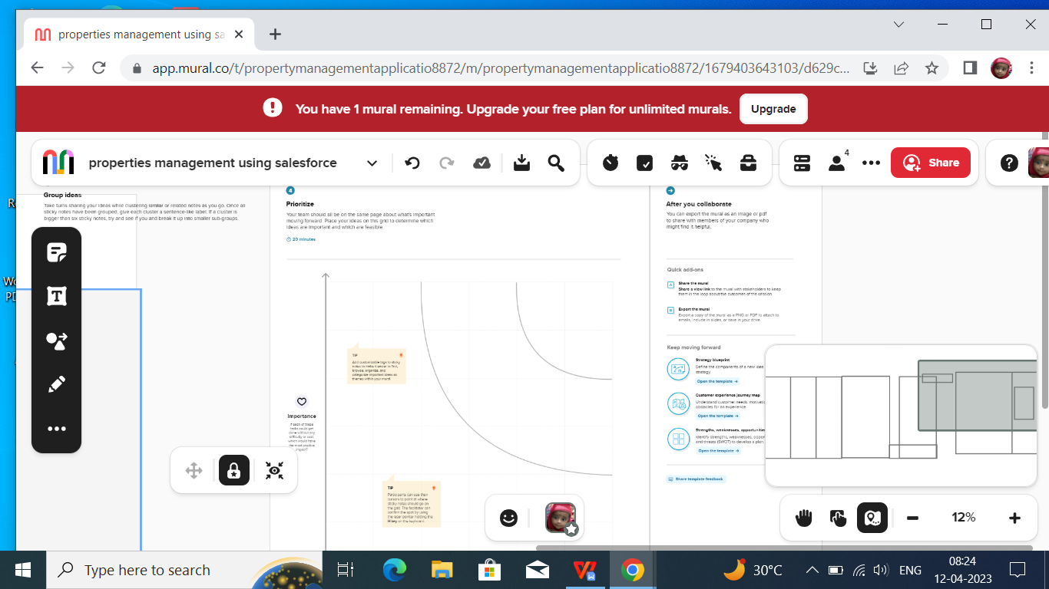

**Result:**

**Data Modle :**

|  |  |
| --- | --- |
| **Object name** | **Fields in the object** |
| **Object -1** | **Fields Label :owner**  **Data type :look up (user,Groups)** |
| **Object -2** | **Fields Label :priority**  **Data type :pick list** |
| **Object -3** | **Fields Label:project name**  **Data type :text (80)** |

### Activity and Screenshot :

### Create Salesforce Org Creating Developer Account :

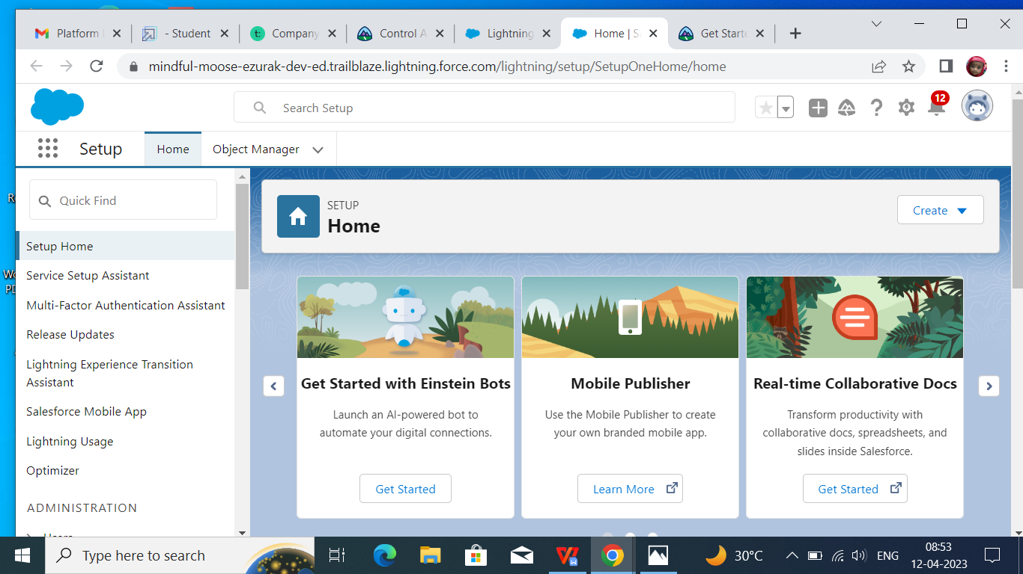

### Object:

### Creation of Loan Amount Object

### Screenshot (10)

## Creation of Project Object

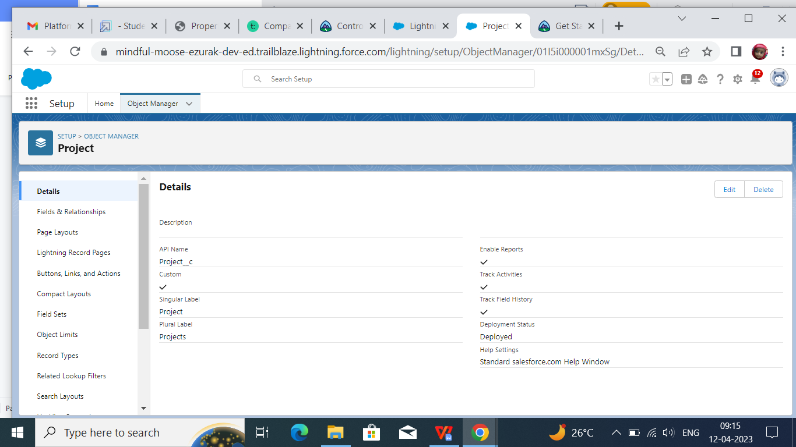

### Lighting app

### Create the sales app

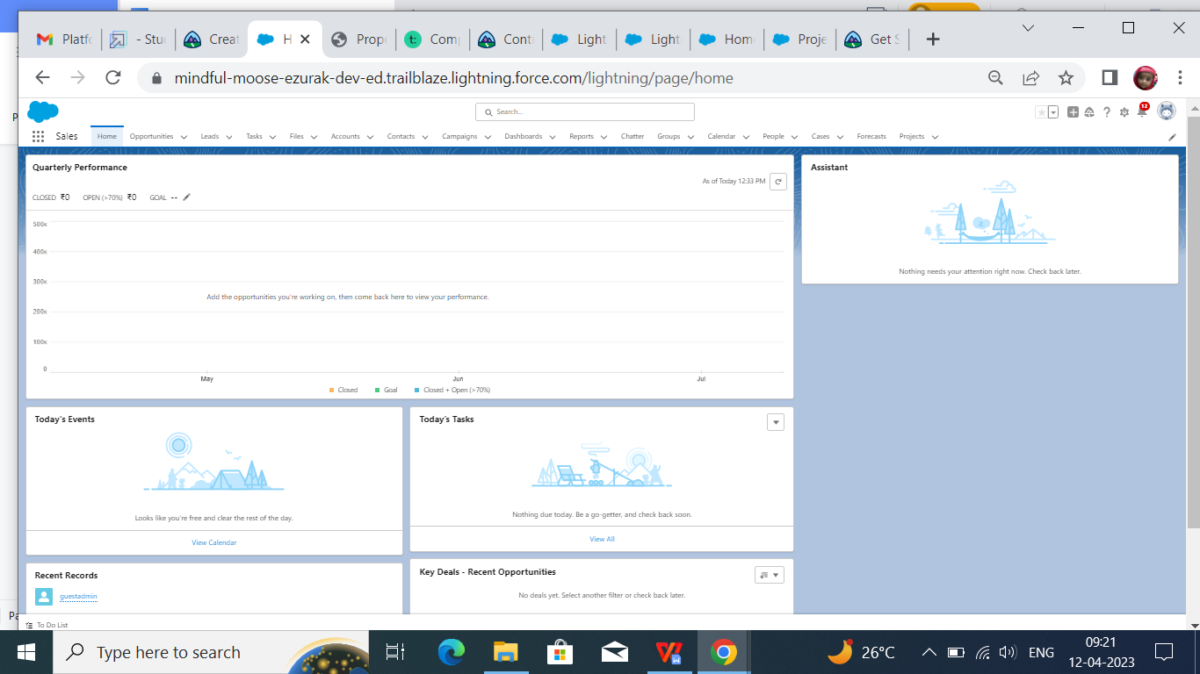

### Field and relationship

### Creation field for the Loan Amount

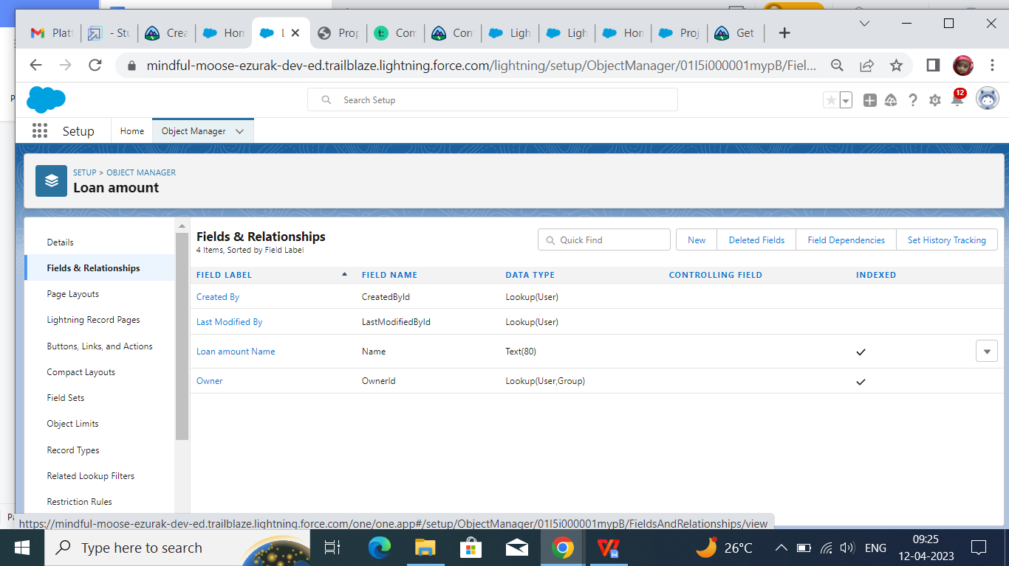

### Creation of Fields for the project

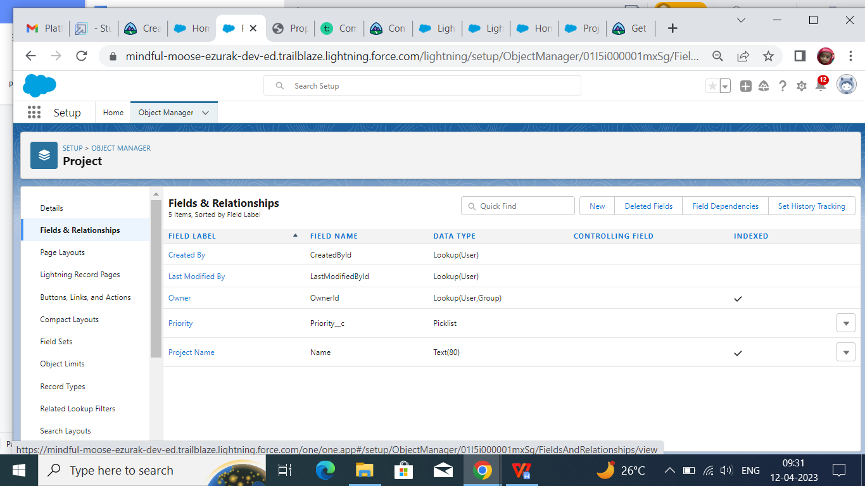

# Profile

# Creation on Profile

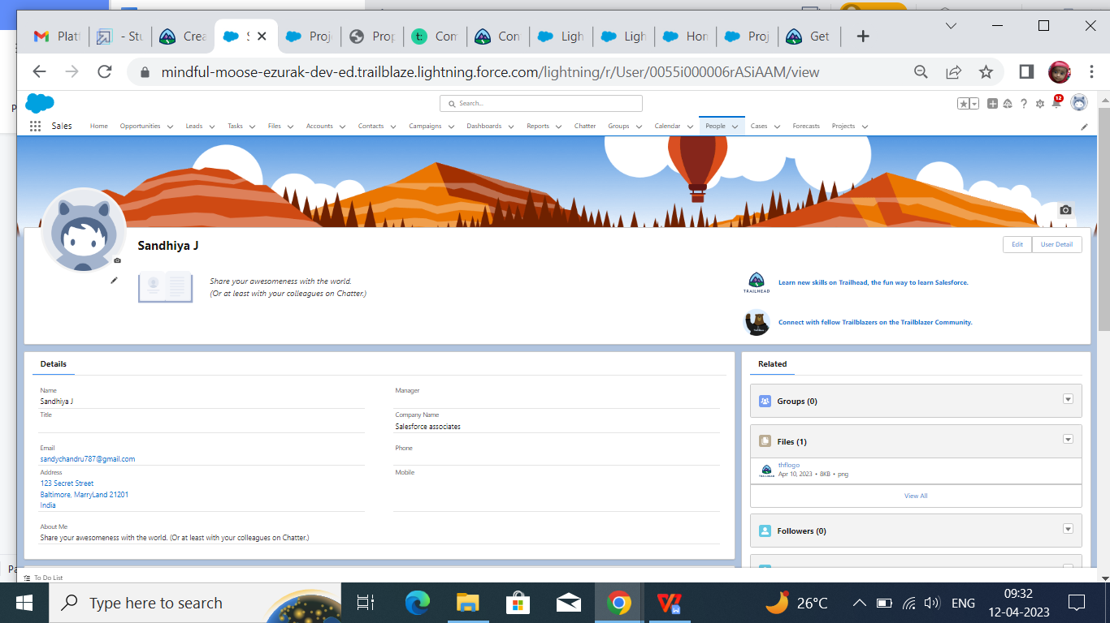

# Permission Sets

### Permission 1

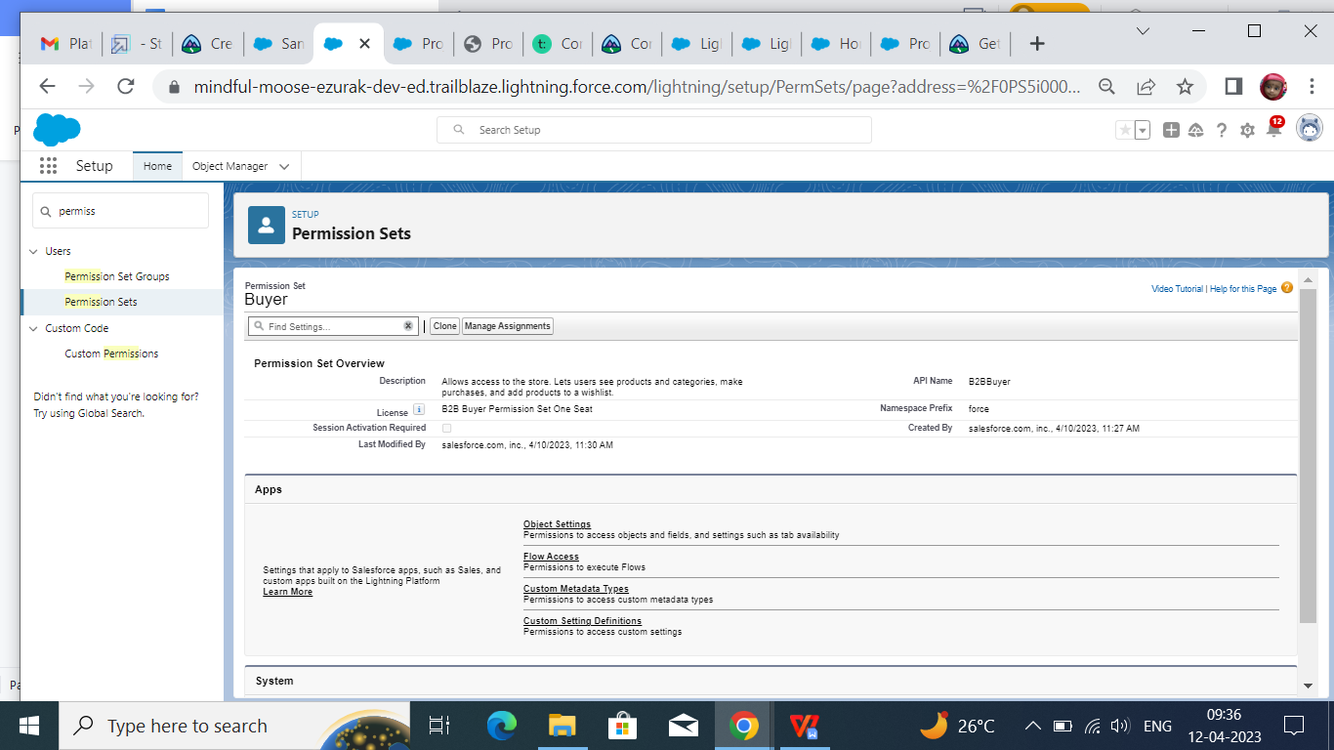

### Permission 2

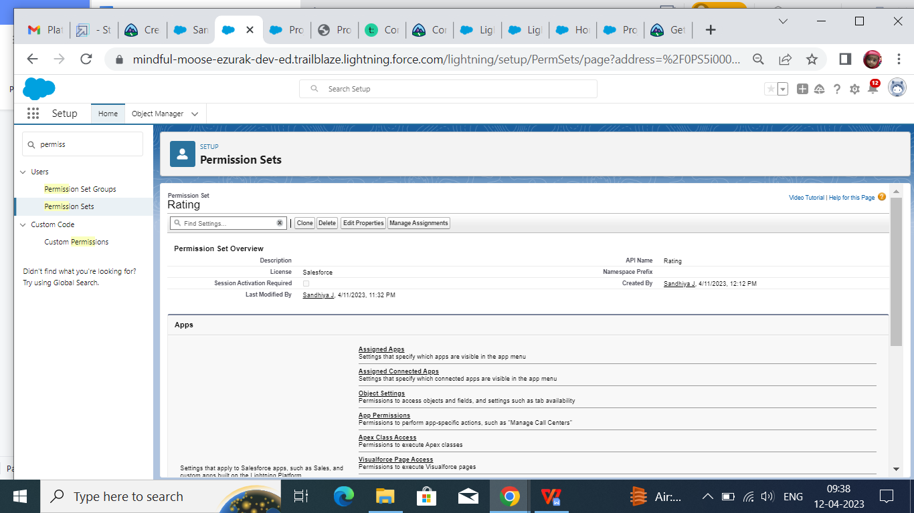

# Reports

# 

## **Trail head Profile public URL :**

**Team lead - <https://trailblazer.me/id/ssaravanan59>**

**Team member 1 - <https://trailblazer.me/id/ssangetha21>**

**Team member 2- <https://trailblazer.me/id/amma123456>**

**Team member 3 - <https://trailblazer.me/id/sandj14>**

# Advantages and Disadvantages :

* Today’s conglomerates are yesterday’s startups .Many topmost real estate companies have startups and scaled great heights .startups are a journey into the unknown ,and only the prudent succeed .winning the trust of customers could be a critical factor for successful startups . property management enables the Salesforce for real estate companies to keep a tract of crucial data about financial and household properties incorporating associated cash flow ,primary tenants , and occupancy rates.
* Salesforce property management has powerful tool to remain associated with client and tenants continuously support further connection ,track key data about business and residential properties,including occupancy rates, essential tenants and revenue and take your productivity, and business growth, to the next level.
* This cloud-based property management software attracts users thanks to:
* Enterprise-level platform security that improves with each release
* Infinite customization of the system
* Over 4,000 native integration both free and paid
* Consolidated databases via integration of various data sources to build a central database of accounts, properties, tenants, or listings.
* Data integration of various data sources
* Streamlined lead management and nurturing with Salesforce to ensure that you can generate leads from various channels and streamline lead-to-deal workflows.
* Automated multichannel lead tracking, Account and Lead management, and routing
* Boosted document management and improved collaboration on contracts, agreements, and deals by defining user roles
* Simplified template-based document generation, tracking, and approval
* Improved management of maintenance requests/tasks/calls
* Simplified tenant on boarding routine and creation of administrative information, service descriptions, and agreements within a real estate app
* Facilitated the rent collection/payment process
* Unified data storage, lease administration, and portfolio management
* Comprehensive reporting & analytic on property status and availability, agents’ KPI, profitability, local and global trends, and real estate market fluctuations
* Forecasting based on interaction history and automated report scheduling
* Simplified renewals and leases management
* Automated tenant notifications.

**Disadvantages of using a property management Salesforce**

* Time-consuming if you choose the wrong system. …
* Might seem expensive for a small business. ..
* Training (cost and time).

**APPLICATION :**

* Best Property Management CRM on Top of Salesforce.
* B Real Asset Management CRM
* Agent Hub Property Administration CRM.
* Rethink Real Estate Administration CRM.
* Property base CRM Property Rent Management CRM**.**

# Conclusion :

It has been observed that the Salesforce CRM is the most beneficial tools these days cloud computing is the backbone of today’s computing .It needs to develop good customer relationship for more profit in the real estate business.